Vision-HD Deployment Instructions

1. Introduction
Vision-HD is a method designed for localization and change detection in autonomous driving and high definition map (HD Map) update. This system is designed to validate the effectiveness and robustness of Vision-HD method. It consists of two main modules: lane markings reconstruction from images, geometric comparison between reconstructed lane markings and HD Map, and registration and evaluation between images and HD Map. This document outlines the steps required to deploy Vision-HD in a production environment, including system requirements, installation instructions, and configuration settings. It assumes a basic understanding of localization, change detection concepts and software development.
In the following sections, we will provide a detailed overview of the system requirements, installation instructions, and configuration settings for deploying Vision-HD. We recommend following these steps carefully to ensure a successful deployment and optimal performance of the system.

2. System Requirements
The program is implemented in C++. Here are some revised system requirements for deploying Vision-HD in a C++ environment:
Hardware:
- CPU: Intel Core i5 or above
- RAM: 2 GB or above
- Storage: 1 GB or above
Software:
- Operating System: Windows 10
- Microsoft Visual Studio 2019

3. Installation Instructions
(1) Extract the source code package “code_VisionHD.zip” to a directory of your choice;
(2) Extract the data package “data_VisionHD.zip” to a directory of your choice;
(3) Ensure that your system meets the minimum hardware and software requirements for running Vision-HD. Refer to the system requirements section of this document for more information.

4. Configuration Instructions

4.1 Command Line Arguments
Configure the Vision-HD executable with the necessary parameters for your specific use case.
To validate the reconstruction method described in our paper section 3 and reproduce the experiments in section 5.1, open the configuration file “03-recon.bat” in a text editor and change the second numeric parameter for reconstruction method. Save your changes.

value | method
0 | fixed
1 | interpolation-based
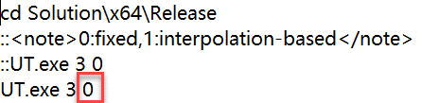
To validate the registration method described in our paper section 4 and reproduce the experiments in section 5.2, open the configuration file “00-regist.bat” in a text editor and change the second numeric parameter for registration method. Save your changes.

value | method
0 | initialize
2 | icp-based
5 | ground truth
6 | cross-entropy-based (proposed)
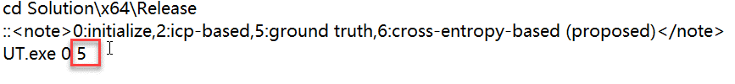

4.2 Configuration File
Modify the input data source and output directory. Double click the shortcuts of “RegConfig.xml”. Modify the value of <data_path> and <mid_path> to the data path you extracted. Save the changes.
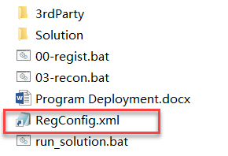

5. Deployment Instructions
We offer two ways to run Vision-HD. One is to run it from the release binary, and the other is to run it from the source code solution.

5.1. Release Binary
To set up the necessary parameters for your specific use case, please refer to the configuration instructions section of this document. Ensure that you include the appropriate arguments when executing the Vision-HD executable and update the data paths as needed.

Double-click the “03-recon.bat” file to run reconstrcution.
The reconstruction experiment will start running. During the experiment, you may see various outputs and progress updates in the command prompt.
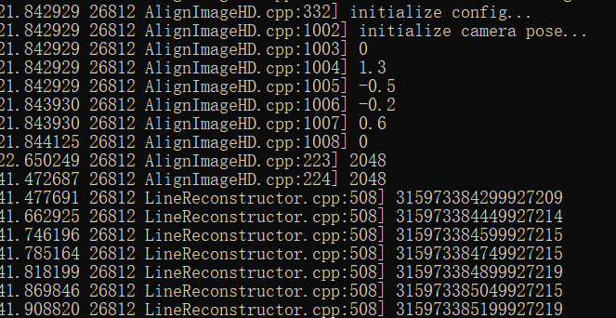
Once the experiment is complete, the reconstruction results will be stored in the designated output directory.
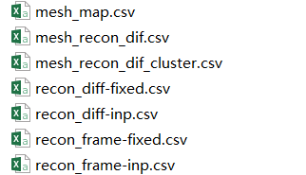

Double-click on the “00-regist.bat” file to run registration.
The registration experiment will start running. During the experiment, you may see various outputs and progress updates in the command prompt.
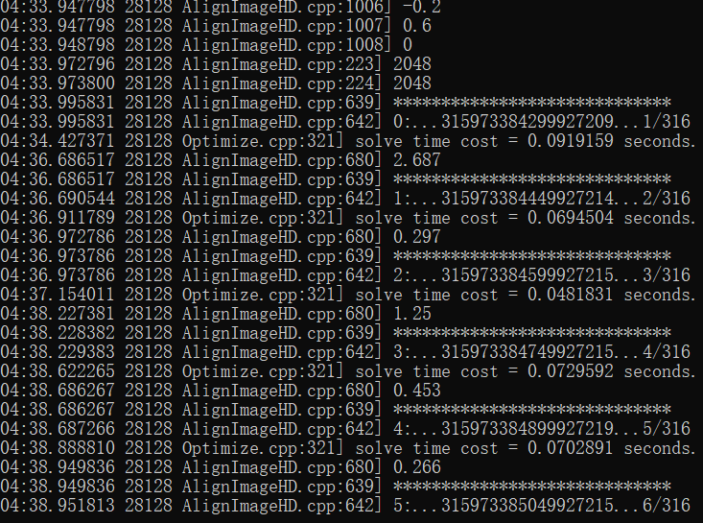
Once the experiment is complete, the registration results will be stored in the designated output directory.
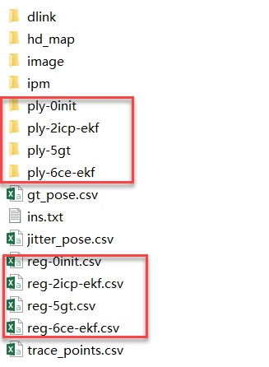

5.2. Source Code
(1) Open the “run_solution.bat” file in a text editor;
(2) Set up the parameters in the as following. Modify the “CURRENT_DIR” parameter to the full path of the “code_VisionHD” directory you extracted. Modify the “VS_PATH” parameter to specify the full installation path of devenv.exe of Visual Studio 2019 on your system. Save the changes;
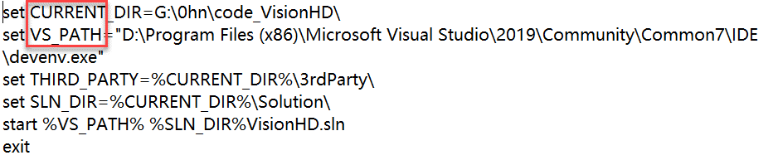
(3) Double-click on the “run_solution.bat” file to run it. This will open the Vision-HD solution named “VisionHD.sln” in Visual Studio 2019;
(4) Once the solution is open, ensure that the configuration of the solution is “Release” and the platform is “x64”;
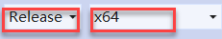
(5) In the Solution Explorer pane, locate the "UT" project. Right-click on the "UT" project and select "Set as StartUp Project" from the context menu. This will set the "UT" project as the startup item for the Vision-HD solution. To confirm that the "UT" project is set as the startup item, the “UT” item should be bolded.
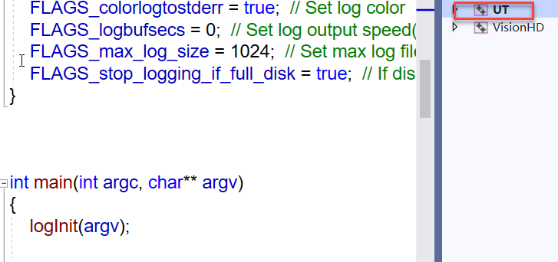
(6) Right click on the "UT" project and select “Properties” from the context menu. In the "UT Property Pages" dialog box, select the "Debug" tab. In the "Command line arguments" field, enter the necessary command line parameters for the "UT" project, according to the configuration instructions for your specific use case. In the "Working directory" field, enter "$(OutDir)" to set the work directory to the output directory of the project. Click the "Apply" button to save the changes. Click the "OK" button to close the "UT Property Pages" dialog box.
(7) Navigate to the working directory of the "UT" project is located. This is typically located in the "code_VisionHD\Solution\x64\Release" directory. Locate at the “RegConfig.xml” file in the “config” folder. Double-click on the “RegConfig.xml” file to open it in a text editor and modify the parameters as described in configuration instructions. Save the changes.
(8) To run the "UT" project, press the F5 key or click on the green play button icon in the Visual Studio toolbar. This will build and execute the "UT" project to validate the methods in Vision-HD.
It is recommended to read the installation instructions carefully and follow them step-by-step to ensure a successful installation. Additionally, if you encounter any errors or issues during the installation process, refer to the troubleshooting section of this document for guidance on how to resolve common problems.

6. Troubleshooting
Problem: Vision-HD executable fails to run, or produces errors during execution.
Solution: Ensure that your system meets the minimum hardware and software requirements for running Vision-HD. Verify that all necessary dependencies and libraries have been installed, and that the Vision-HD executable has been compiled correctly. Check the configuration settings to ensure that they are correct for your specific use case.

Problem: Vision-HD produces incorrect or unexpected output.
Solution: Check the configuration settings to ensure that they are correct for your specific use case. Verify that the input data source is configured correctly and that the data is being processed correctly. Check that the object detection settings are set appropriately for the objects you are trying to detect.

Problem: Vision-HD runs slowly or crashes during execution.
Solution: Check the system resources to ensure that there is sufficient memory and processing power available. Verify that the hardware and software configurations meet the recommended requirements for running Vision-HD. Consider reducing the size of the input data source or adjusting the object detection settings to improve performance.

Problem: Vision-HD produces inconsistent output across different environments or input data sources.
Solution: Check that all environments and input data sources are configured consistently and that they meet the minimum requirements for running Vision-HD. Verify that the object detection settings are consistent across all environments and input data sources.

If you encounter any other issues or errors while deploying or using Vision-HD, please consult the documentation or user guide for your specific implementation of Vision-HD. Additionally, you may consider contacting the Vision-HD support team for further assistance.

7. Conclusion
Deploying Vision-HD can provide a tool for validating the methods proposed in this paper. By following the installation and deployment instructions outlined in this document, you can set up a fully functional Vision-HD system. The system requirements and installation instructions provide a clear roadmap for setting up the necessary hardware and software configurations, while the deployment instructions offer guidance on how to configure the Vision-HD executable with the necessary parameters. We hope that this document has been helpful in guiding you through the deployment of Vision-HD. If you have any questions or concerns, please refer to the documentation or user guide for your specific implementation of Vision-HD, or contact the Vision-HD support team for further assistance.

